|  |
| --- |
| Sir Syed University of Engineering and Technology  Department of Computer Science and Information Technology  Spring 2023  Artificial Intelligence  ASSIGNMENT 02    Semester: VI Max Marks: 03  Due Date: 15th May, 2023 Batch: 2020F |

**ROLL NUMBER** : 2020F-CS-030 (A)

**NAME**: SYED OBAID HASHMI

## Question 1S

Iterative Deepening Search is the combination of Breadth-First Search & Depth-First Search, what benefits do we get in Iterative Deepening Search that lack in Breadth-First Search & Depth-First Search?

# 

**ANS:**

Iterative Deepening Search (IDS) is a search algorithm that combines the best features of Breadth-First Search (BFS) and Depth-First Search (DFS). iterative deepening search performs a series of depth-limited searches, gradually increasing the depth limit until a solution is found.

One of the main benefits of iterative deepening search over BFS and DFS is that it finds the shortest path to the goal node in a tree with uniform edge costs. Unlike DFS, IDS guarantees completeness, i.e., it will find a solution if one exists. Unlike BFS, IDS has a space complexity of O(bd), where b is the branching factor and d is the depth of the shallowest solution. This is much more efficient than BFS, which has a space complexity of O(b^d).

Another advantage of iterative deepening search is that it can handle infinite or unknown search spaces. In such cases, IDS can be used to explore the search space in a systematic way without the need to know the depth of the search space beforehand.

IDS can be used in situations where the cost of moving to a neighboring node is not known beforehand, unlike in BFS where all the costs are assumed to be equal. IDS is more efficient than BFS in such cases because it explores the search space in a depth-first manner but with the guarantee of finding the shortest path to the goal node.

## Question 2

Solve for Iterative Deepening Search & Depth Limit Search. Consider the search tree shown in Figure 01. The number next to each edge is the cost of the performing the action corresponding to that edge. You start from the node A. The goal is the reach node G. (Assume depth limit 2 in case of Depth Limit Search).

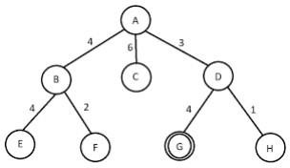

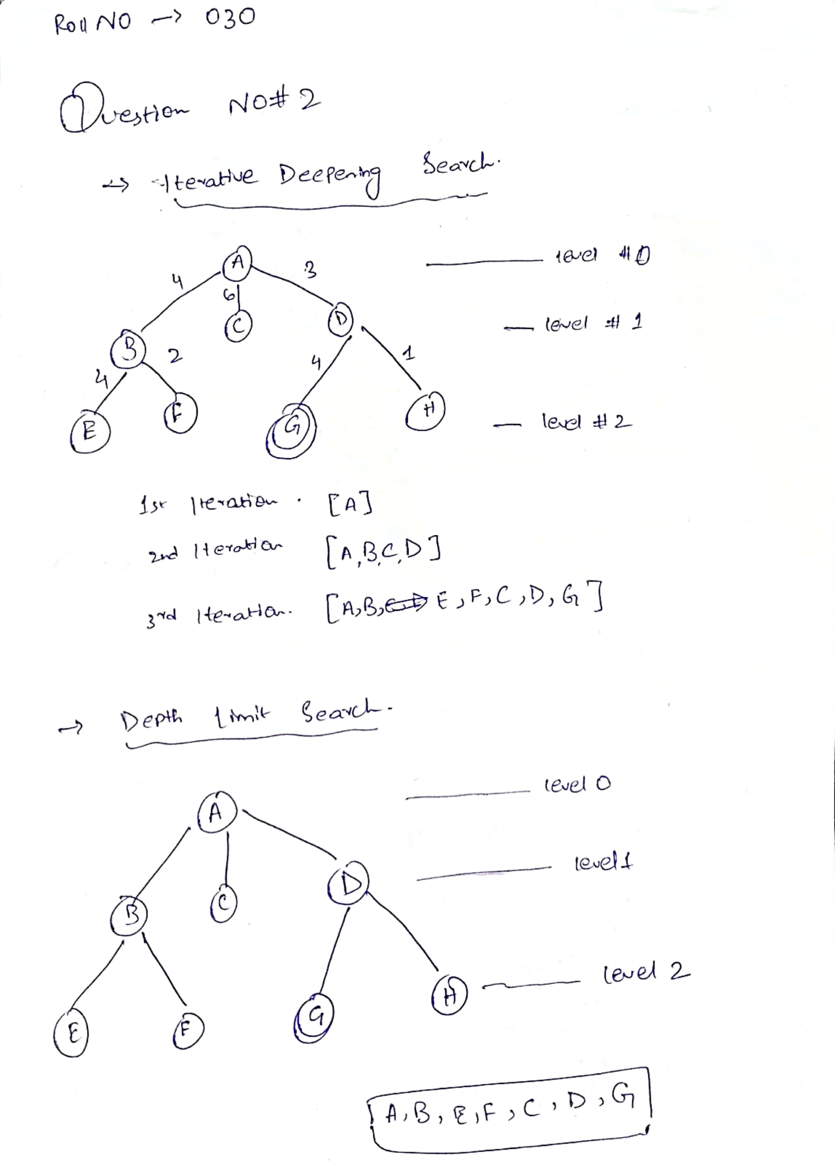

**Question 3**

Everyone chooses their desired universities based on their career plans after graduation. Let’s draw a graph of your career path as shown in Fig: 02. Where the starting point of your career path is S=SSUET and end point of your career is R=Retirement. There are multiple stops in between (you can consider them as job switches, different occupations etc.). The edge distance included in your chart roughly represents the "transition cost" or path cost between these occupations. You also have heuristic (node-to-goal) distances which represent your preconceptions about how many more years you have to work until you retire. For example, you think it will take 25 years to go from SSUET (S) to retirement (R), 30 years from Post Graduate School (B), but only 2 years from Entrepreneur (E).

A = Government | B = Post Graduate School | C = Professor | D = Software House | E = Entrepreneur.

**Note: First place the node value of “D” then solve the question. Heuristic value (node value) for “D” is the sum of your roll number. Suppose your roll number is 2018-CS-177 so the sum of your roll number will be: 1+7+7=15. Suppose you want to retire after the minimum number of different jobs.**

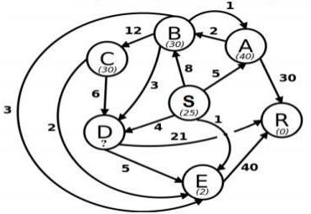

Fig: 02

Suppose you want to retire after the minimum number of different jobs. What is the number of nodes from S to R?

|  |
| --- |
| 1. **Path for Greedy BFS** |
| 1. **Search Path for A\*** |
| 1. **Search Path for UCS** |
| 1. **Best Algorithm (among all three)** |
| 1. **Nodes Sequence of best solution (from S to R)** |
| 1. **Number of nodes** |

